Topic: WhatsAPP and other messaging applications
When I am done this lesson, I will know:
- What the most popular messaging application are
- What WhatsApp is
- The main features of WhatsApp
- How to set up WhatsApp on my device

Pre and Post Self-Assessment
 | Pre | Pre | Post | Post
 | Yes, I know this | No, I want to learn this | Yes, I know this | I still need more practice to learn this
I know what the most popular messaging applications are
I know about WhatsApp and how to set it up on my device

New Words and Terms
agnostic
encryption
two-factor authentication

Review | Application  Any program, or group of programs, that is designed for the end-user. Application software (also called end-user programs) includes such things as database programs, word processors, web browsers, and spreadsheets.  App  The word "app" is a short form for "application."

Popular Messaging Applications
There are many popular messaging applications.
- Smartphones have a texting function built in. This is one of the simplest ways to message with others.
- Facebook has a messaging app that is built into the platform and also has a standalone app. Both the sender and receiver need to have a Facebook account to use the messaging feature. The app also allows you to do video calls.
- Instagram has a messaging feature built in. Both the send and the receiver need to have an Instagram account to use the messaging feature.
- Apple products (e.g. iPad, iPhone, Mac computers) have their own messaging app and video app built in. Both the send and the receiver need to have an Apple product and an Apple ID to use the messaging and video apps.
- WhatsApp is a messaging and video app that works across platforms.

What is WhatsApp?
WhatsApp is one of the most popular free text and voice messaging apps. You can use it to send messages, make calls, and have video chats. You can also use it to send documents, photos and videos.
WhatsApp can be used on a desktop or laptop computer and on mobile devices.
WhatsApp is agnostic which means it works across all different systems and platforms. WhatsApp uses wifi or cellular data and can be used worldwide.
Both the sender and the receiver must have WhatsApp installed in order to communicate using the app. You stay logged into the app all the time so you never miss a message. If you shut the app or turn off your device, messages that came in when your app was closed or device shutdown will be there when you reopen the app or turn your device back on.
WhatsApp has many security features:
- End-to-end encryption which means any messages that flow through the platform can only be seen by the send and receiver
- The app doesn’t store your personal information
- Only people you approve as contacts can message you
- Uses two-factor authentication

Source: https://www.digitaltrends.com/mobile/what-is-whatsapp/

How to Set up WhatsApp on Your Device
- Download WhatsApp to your device. Once it is downloaded, click on the app to open.
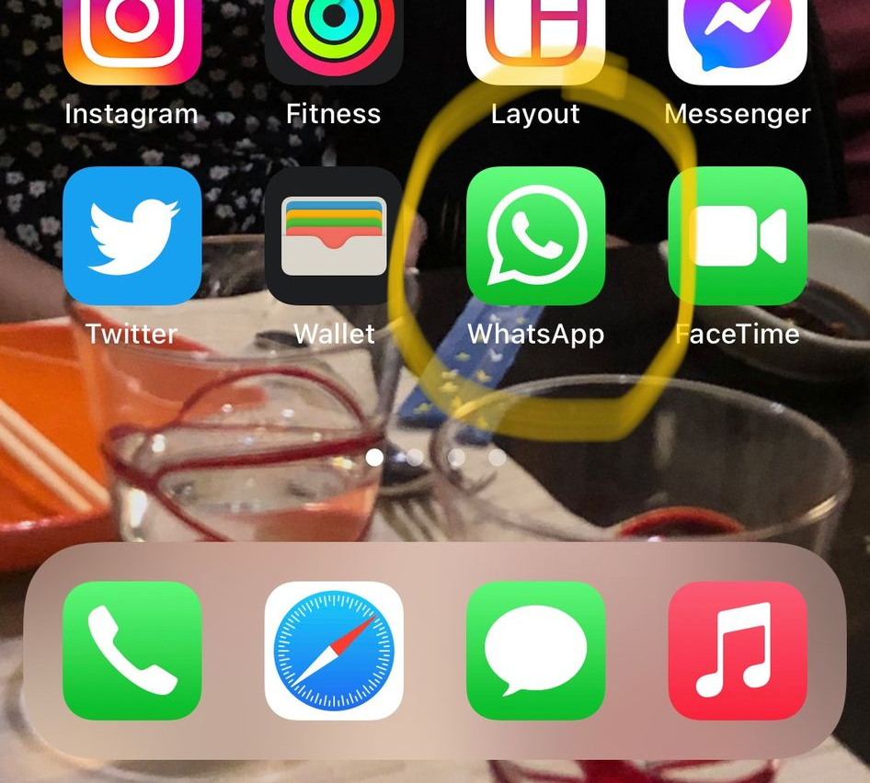

- The “Welcome to WhatsApp” screen appears. You have to agree to the Privacy Policy and Terms of Service before you can continue. Click on “Privacy Policy” to open and read the policy. Click on “Terms of Service” to read the terms of service. Click on “Agree & Continue” when you are done.
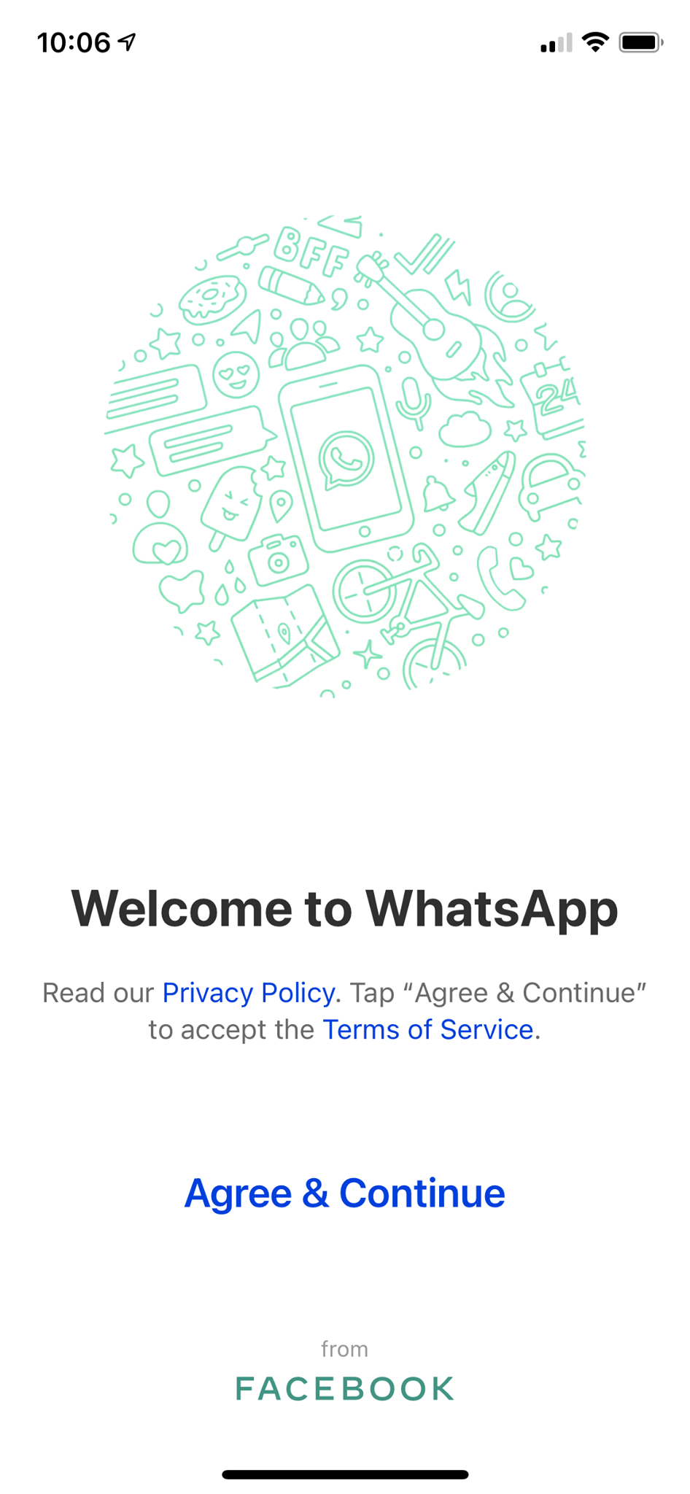

- Enter your phone number.
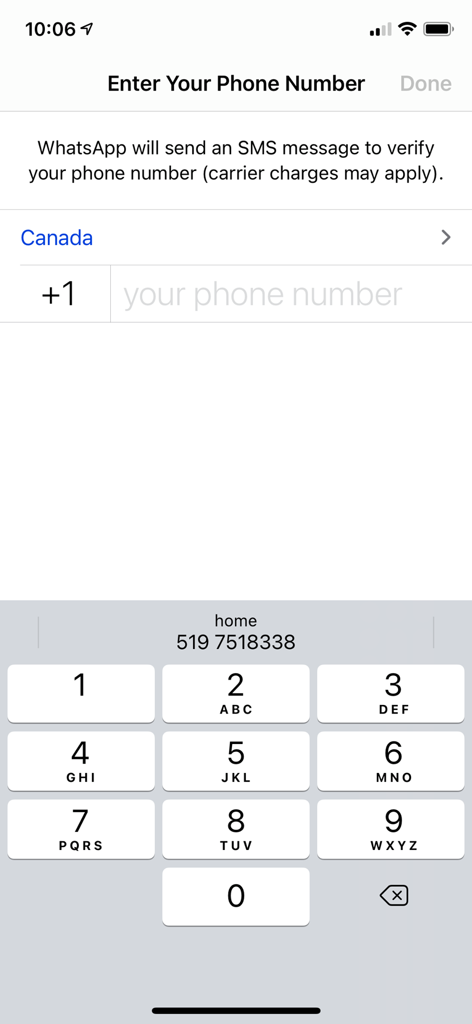

- You will receive a code by text. Enter this code.


- Set up your profile. Type your name in. You can upload a picture by clicking “add photo”.
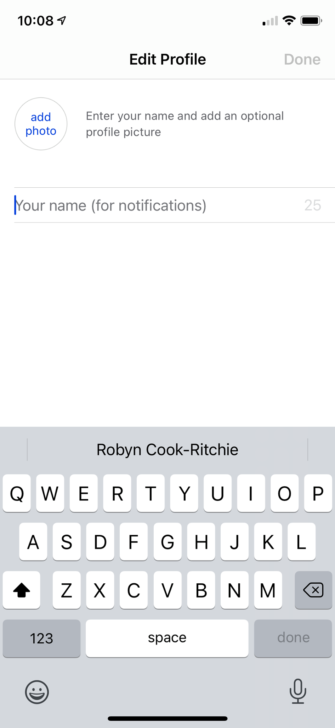

- This screen will pop up. Tap on the icon.
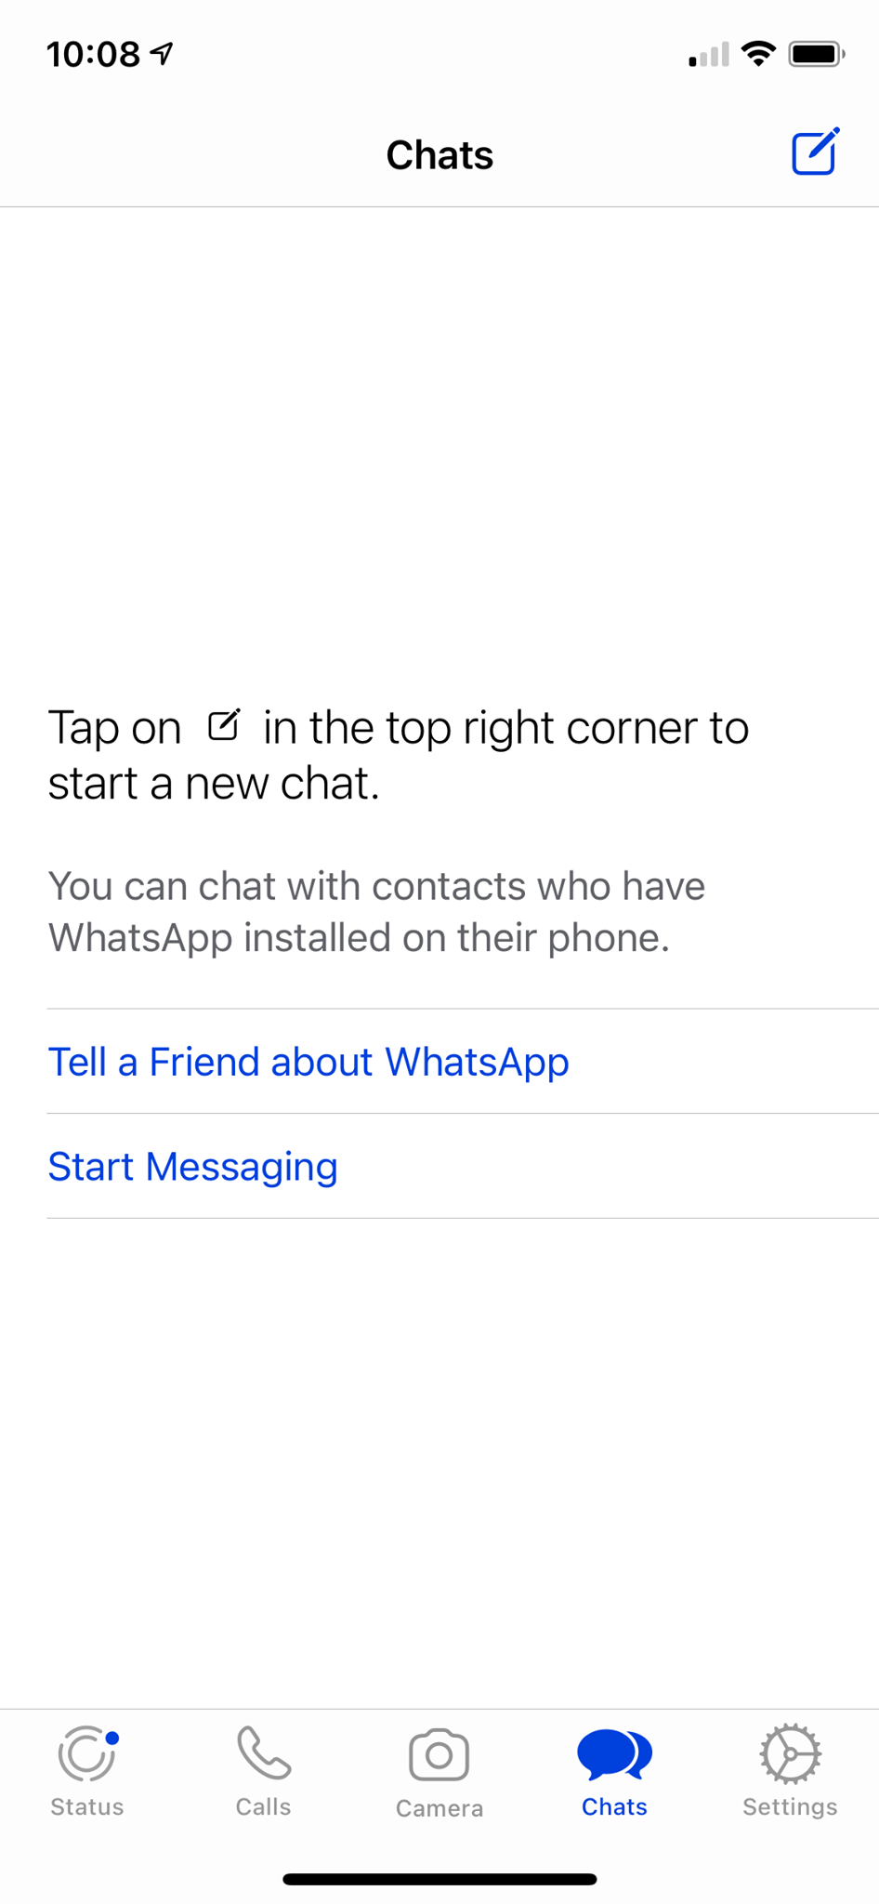

- This screen will allow you to add groups and contact to chat.

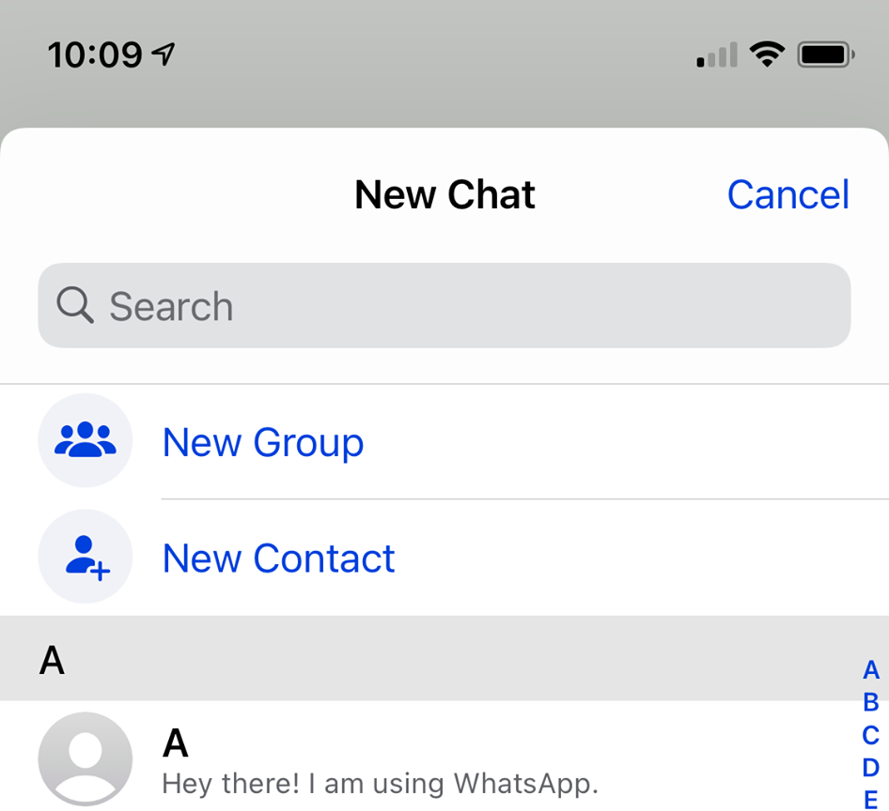
WhatsApp will list people in your contacts who currently use the app so you can find them quickly. You can create groups (e.g. work group, family group) with up to 256 participants.
Features of WhatsApp
The features can be accessed from the bar at the bottom. There are five features:
- Status
- Calls
- Camera
- Chats
- Settings
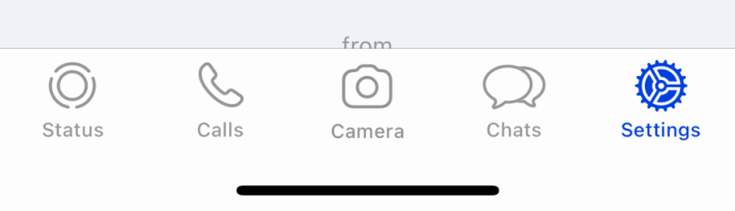

Status
Click on the status icon in the bottom bar to open this feature. Status lets you share contacts, videos and texts with all your contacts that disappear after 24 hours. Status is like “stories” on Facebook and Instagram.

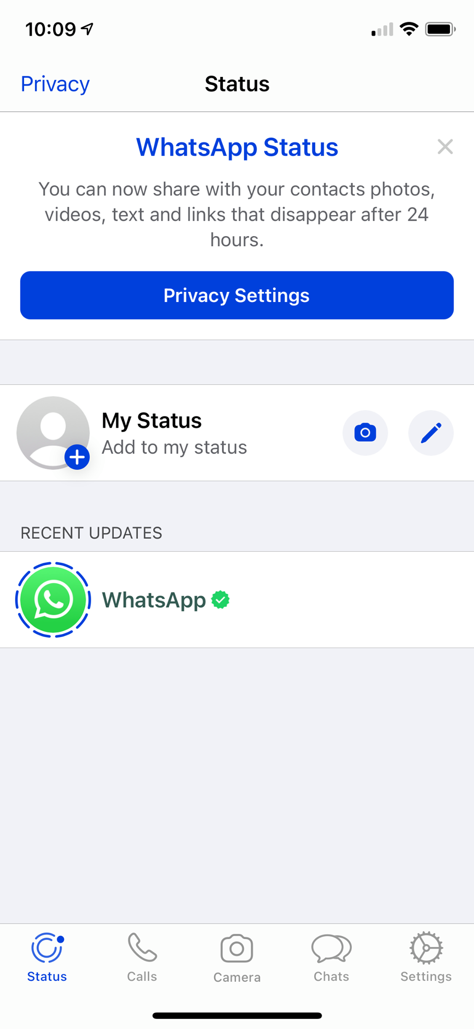

Calls
To make a call, click on the “calls” icon in the bottom bar to open this feature. To place a call, follow the instructions.
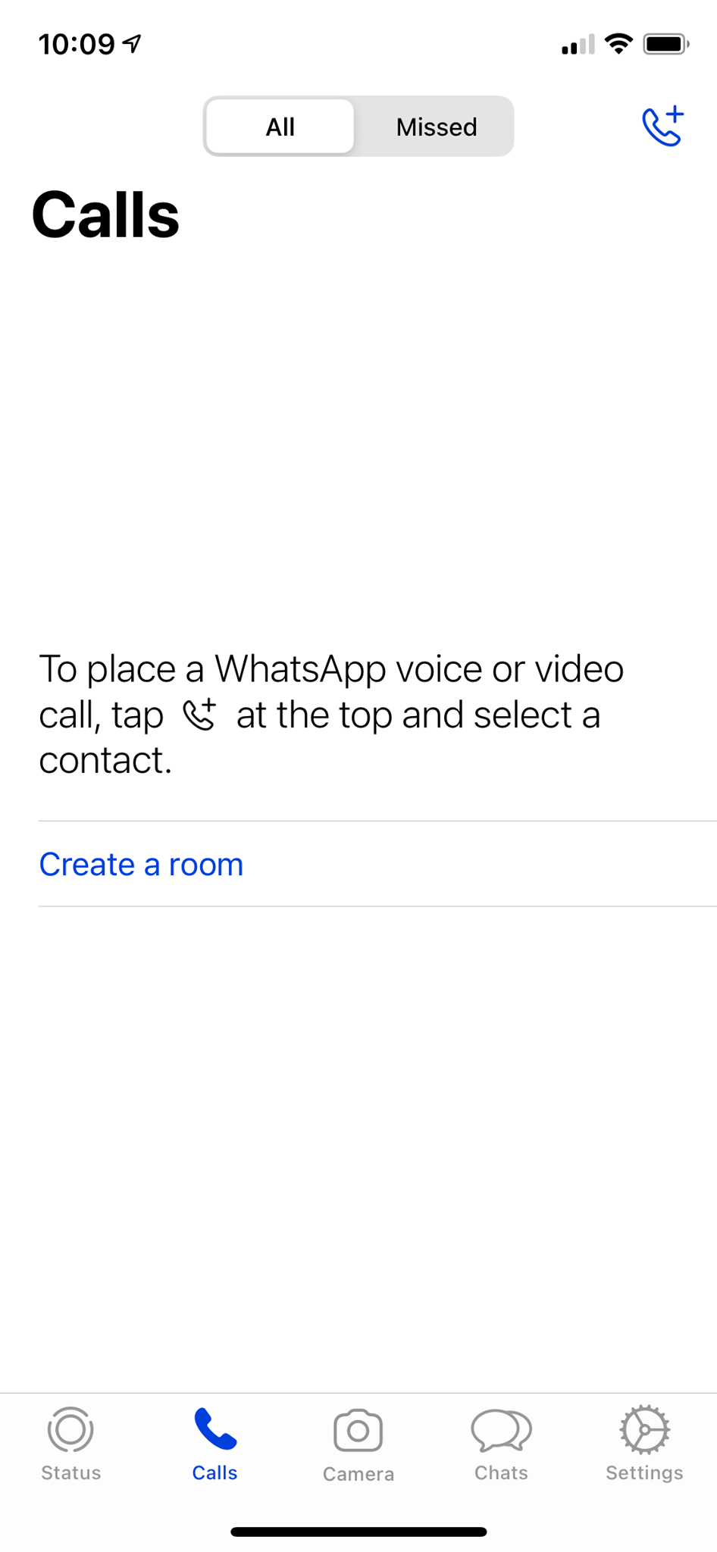
Video calls are limited to 8 participants.

Camera
The first time you open the camera it will ask you for permission to access the camera on your device.
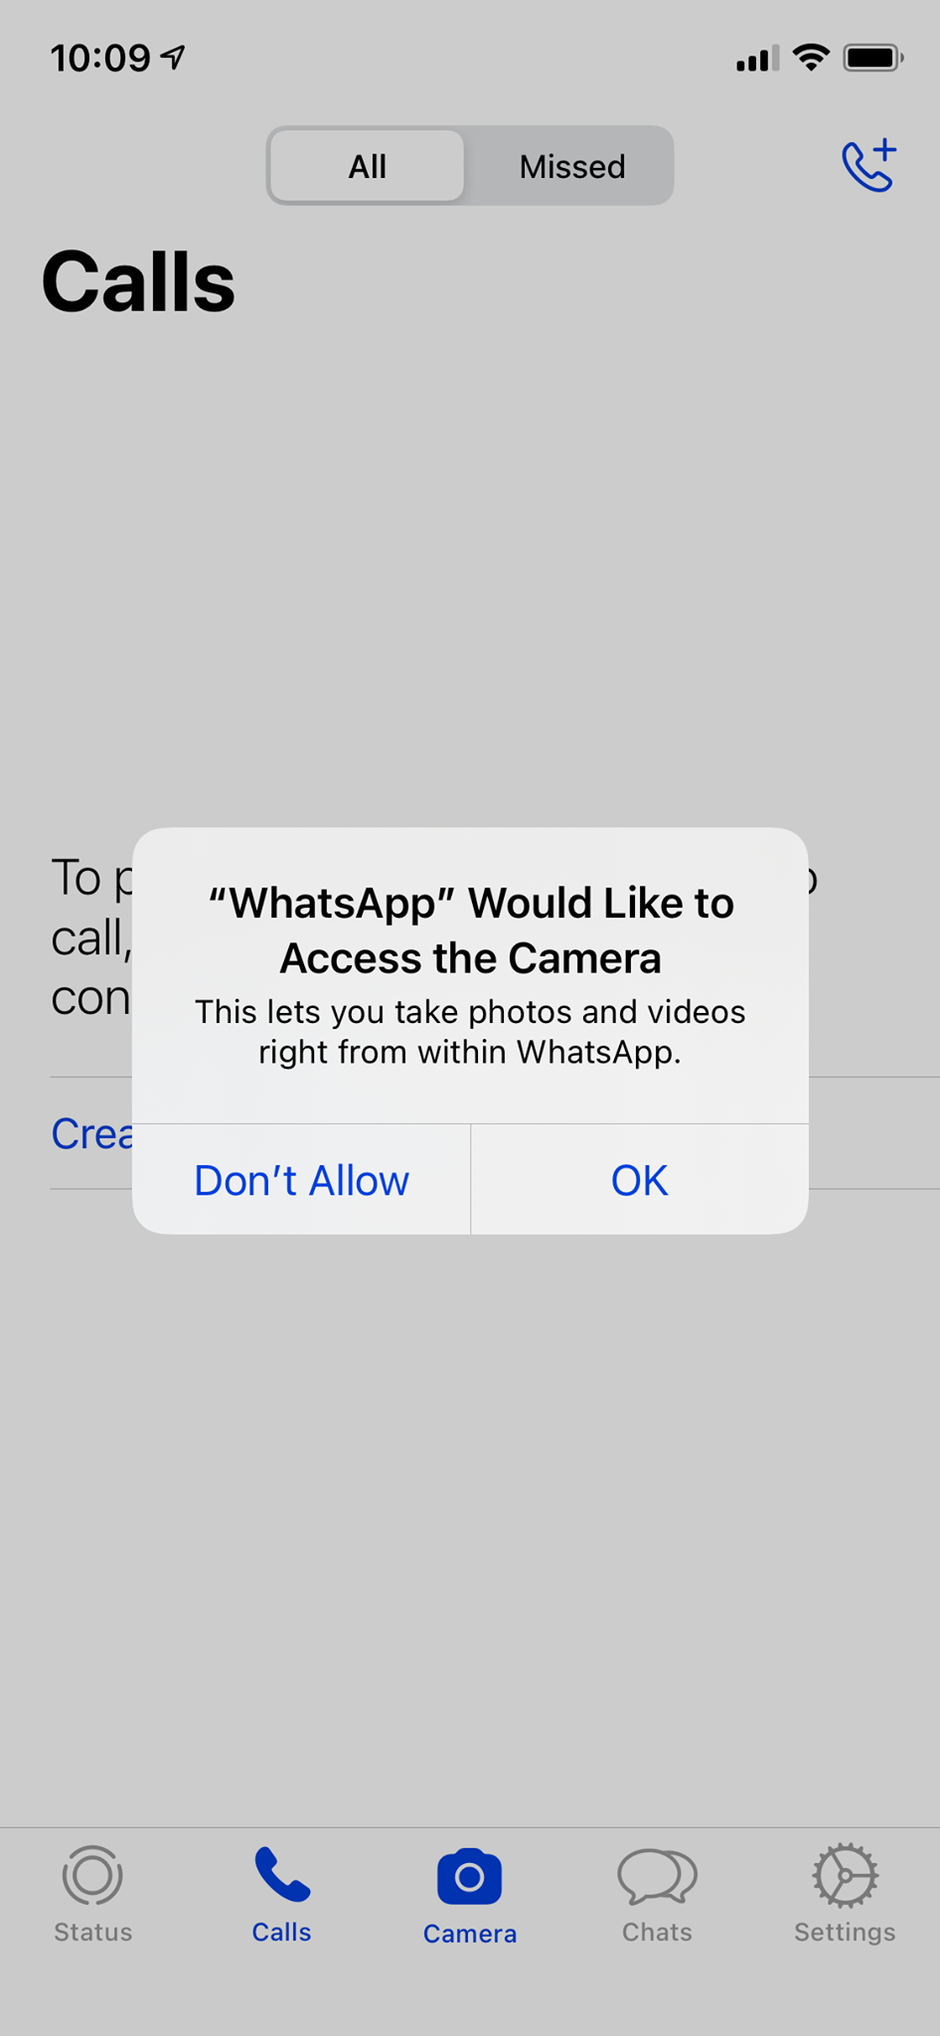

You will then be asked for permission to access the photos on your device.
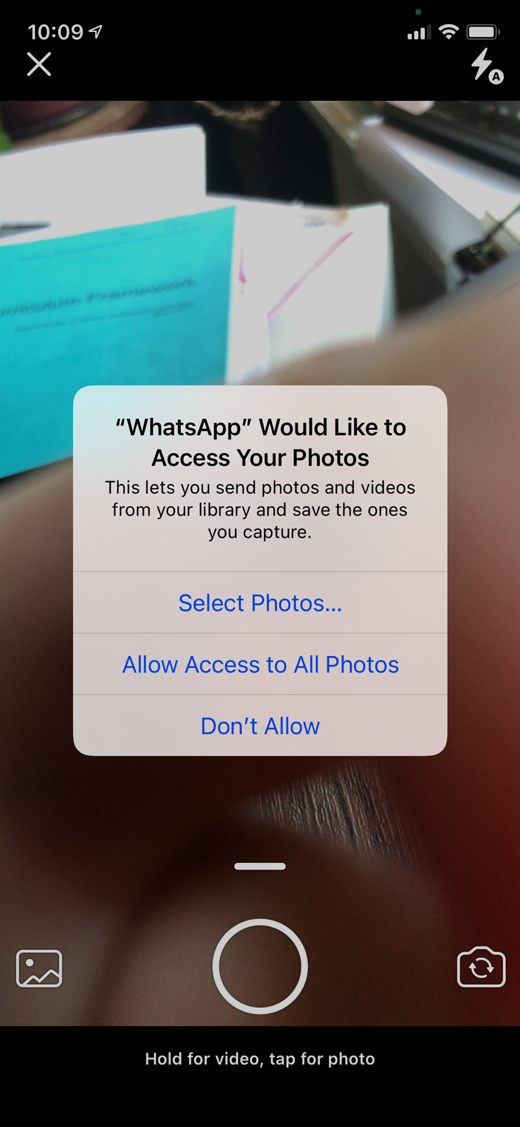

The maximum size for a file, photo or video is 100 MB. You can access photos and videos from the camera on the device. You can also use the camera feature to shoot photos and videos from within the app.

Chats
To start a chat, click on the “chats” icon in the bottom bar to open this feature. To start a chat, follow the instructions.

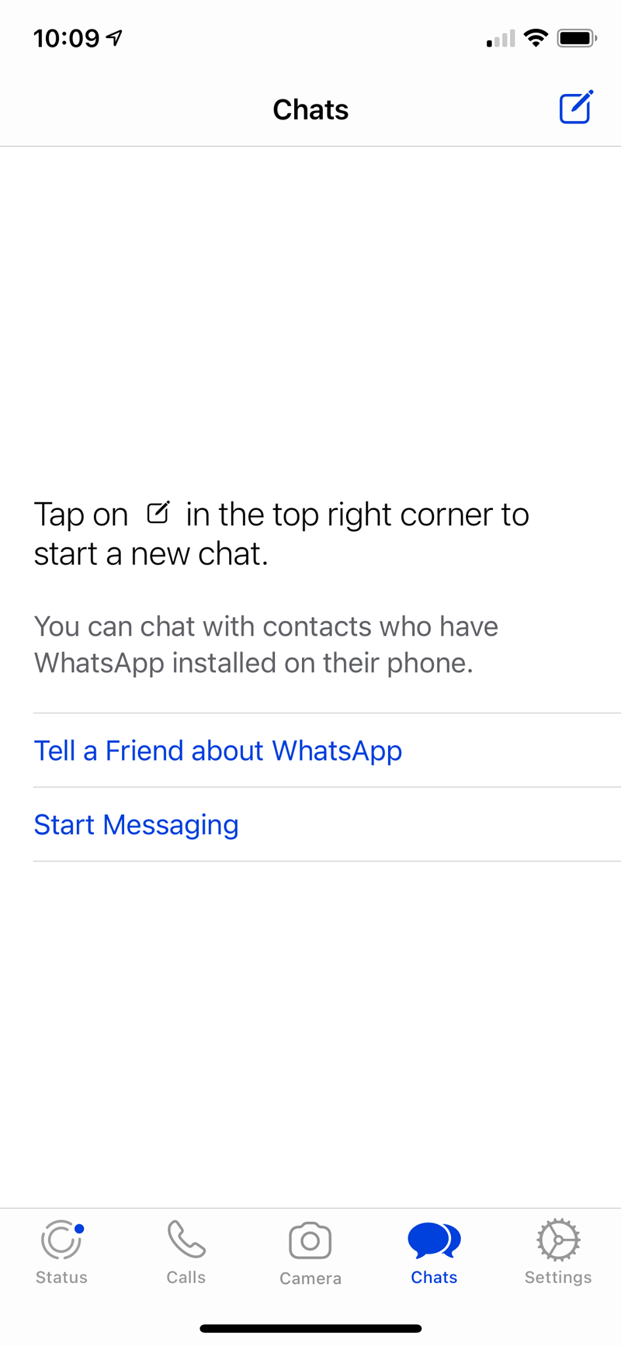
Your chats appear in text bubbles. They have a timestamp. You are notified when the recipient has read your text.

Status
The last feature is settings. This is where you can review and change your account settings, access your chat, check how much storage you have, and access help.

Discussion Questions
1. What is an advantage to using WhatsApp instead of Facetime?

Check Your Knowledge
Name three different messaging platforms.
1.
2.
3.

Try this/Practice
Set up a WhatsApp account on your device.
Find or add one other contact and send a message.

Optional: I Want to Learn More

 | Watch this videos in this WhatsApp Guide playlist to become a WhatsApp expert  Source: Tech Boomers | https://www.youtube.com/playlist?list=PLk3xjyeTggSacPdub--Q4grk7rxZMqMSu

Ontario Adult Literacy Curriculum Framework Connection
Competency | Task Group(s)
Find and Use Information | - Read Continuous Text (L2-Involves on text, may include unfamiliar elements)  - Interpret Documents (L1 - extracts information from tables/forms, begins to identify sources and evaluate information)  - Extract Information from Films, Broadcasts and Presentations
Communicate Ideas and Information | - Interact with Others (L2 - discuss)  - Writes Continuous Text (L1-Conveys simple ideas and factual information)
Use Digital Technology | - Download and set up an app on a device

Icons: Flaticon.com
Images: Original




Literacy Link South Central
(March 2021)
www.llsc.on.ca literacylink@llsc.on.ca

